Final Project: Incident Response Exercise & Report

Your Task
You have been assigned to work incident clean-up as part of the Sifers-Grayson Blue Team. Your task is to assist in analyzing and documenting the incident described below. The Blue Team has already created a set of enterprise architecture diagrams (see figures 1-4) to help with your analysis of the incident and preparation of the incident report as required by the company’s contracts with the federal government. After completing their penetration tests, the Red Team provided Sifers-Grayson executives with a diagram showing their analysis of the threat environment and potential weaknesses in the company’s security posture for the R&D DevOps Lab (see figure 5).

Your Deliverable
Complete and submit the Incident Report form found at the end of this file. Consult the “Notes to Students” for additional directions regarding completion of the form.

Overview of the Incident
Sifers-Grayson hired a cybersecurity consulting firm to help it meet the security requirements of a contract with a federal agency. The consulting firm’s Red Team conducted a penetration test and was able to gain access to the engineering center’s R&D servers by hacking into the enterprise network through an unprotected network connection (see figure 2). The Red Team proceeded to exfiltrate files from those servers and managed to steal 100% of the design documents and source code for the AX10 Drone System. The Red Team also reported that it had stolen passwords for 20% of the employee logins using keylogging software installed on USB keys that were left on the lunch table in the headquarters building employee lounge (see Figure 3). The Red Team also noted that the Sifers-Grayson employees were quite friendly and talkative as they opened the RFID controlled doors for the “new folks” on the engineering staff (who were actually Red Teamers).
The Red Team continued its efforts to penetrate the enterprise and used a stolen login to install malware over the network onto a workstation connected to a PROM burner in the R&D DevOps lab (See Figure 3). This malware made its way onto a PROM that was then installed in an AX10-a test vehicle undergoing flight trials at the Sifers-Grayson test range (See Figures 1 and 4). The malware “phoned home” to the Red Team over a cellular connection to the R&D center. The Red Team took control of the test vehicle and flew it from the test range to a safe landing in the parking lot at Sifers-Grayson headquarters.

Background
Sifers-Grayson is a family owned business headquartered in Grayson County, Kentucky, USA. The company’s physical address is 1555 Pine Knob Trail, Pine Knob, KY 42721. The president of the company is Ira John Sifers, III. He is the great-grandson of one of the company’s founders and is also the head of the engineering department. The chief operating officer is Michael Coles, Jr. who is Ira John’s great nephew. Mary Beth Sifers is the chief financial officer and also serves as the head of personnel for the company.

Recent contracts with the Departments of Defense and Homeland Security have imposed additional security requirements upon the company and its R&D DevOps and SCADA labs operations. The company is now required to comply with NIST Special Publication 800-171 Protecting Controlled Unclassified Information in Nonfederal Information Systems and Organizations. The company must also comply with provisions of the Defense Federal Acquisition Regulations (DFARS) including section 252-204-7012 Safeguarding Covered Defense Information and Cyber Incident Reporting. These requirements are designed to ensure that sensitive technical information, provided by the federal government and stored on computer systems in the Sifers-Grayson R&D DevOps and SCADA labs, is protected from unauthorized disclosure. This information includes software designs and source code. The contract requirements also mandate that Sifers-Grayson report cyber incidents to the federal government in a timely manner.

SCADA Lab
The SCADA lab was originally setup in 1974. It has been upgraded and rehabbed several times since then. The most recent hardware and software upgrades were completed three years ago after the lab was hit with a ransomware attack that exploited several Windows XP vulnerabilities. At that time, the engineering and design workstations were upgraded to Windows 8.1 professional. A second successful ransomware attack occurred three months ago. The company paid the ransom in both cases because the lab did not have file backups that it could use to recover the damaged files (in the first case) and did not have system backups that it could use to rebuild the system hard drives (in the second case).
The SCADA Lab is locked into using Windows 8.1. The planned transition to Windows 10 is on indefinite hold due to technical problems encountered during previous attempts to modify required software applications to work under the new version of the operating system. This means that an incident response and recovery capability for the lab must support the Windows 8.1 operating system and its utilities.

R&D DevOps Lab
The R&D DevOps Lab was built in 2010 and is used to develop, integrate, test, support, and maintain software and firmware (software embedded in chips) for the company’s robots, drones, and non-SCADA industrial control systems product lines. The workstations in this lab are running Windows 10 and are configured to receive security updates per Microsoft’s monthly schedule.

Enterprise IT Operations
The company uses a combination of Windows 10 workstations and laptops as the foundation of its enterprise IT capabilities. The servers in the data center and the engineering R&D center are built upon Windows Server 2012.

Issues Summary:
- Newly won government contracts now require compliance with DFARS §252.204-7008, 7009, and 7012
  - http://www.acq.osd.mil/dpap/dars/dfars/html/current/252204.htm
  - http://www.acq.osd.mil/se/docs/DFARS-guide.pdf
- Derivative requirements include:
  - Implementation of and compliance with NIST SP 800-171 Protecting Controlled Unclassified Information in Nonfederal Information Systems and Organizations http://nvlpubs.nist.gov/nistpubs/SpecialPublications/NIST.SP.800-171.pdf
  - Compliance with DFARS 252.239-7009 Representation of Use of Cloud Computing and 7010 Cloud Computing Services (see http://www.acq.osd.mil/dpap/dars/dfars/html/current/252239.htm)
- Additional Contractual Requirements for Lab Operations include:
  - Incident Response per NIST SP-800-61 (Computer Security Incident Handling Guide)
  - SCADA Security per NIST SP 800-82 (Guide to Industrial Control Systems Security)
  - Software / Systems Development Lifecycle (SDLC) Security per NIST SP 800-64 (Security Considerations in the System Development Life Cycle)
  - Configuration Management per NIST SP 800-128 (Guide for Security-Focused Configuration Management of Information Systems)

Notes to Students:
- Your final deliverable should be professionally formatted and should not exceed 10 pages. The goal is to be clear and concise in your reporting of your analysis of this incident.
- You may include annotated diagrams if necessary to illustrate your analysis and/or make your point(s). You may use the figures in this assignment as the foundation for diagrams in your final report (no citations required).
- Use the NIST Incident Handling Process (see Table 1) to guide your incident analysis.
- You may assume that the company has implemented one or more of the IT products that you recommended in your Case Studies for this course. You may also assume that the company is using the incident response guidance documents that you wrote for your labs and that the associated operating systems utilities are in use (e.g. you can assume that system backups are being made, etc.).
- DOCUMENT YOUR ASSUMPTIONS about people, processes, and technologies as if they were fact. But, don’t change any of the factual information provided in the incident report from the Red Team.
- Use the incident report form that appears at the end of this file. Copy it to a new MS Word document. After you perform your incident analysis, fill in the required information, attach the file to your assignment folder entry, and submit it for grading as your final project.
- For section 1 of the form, use your own name but provide reasonable but fictitious information for the remaining fields.
- For section 2 of the form, assign IP addresses in the following ranges to any servers, workstations, or network connections that you need to discuss.
  - R&D Center 10.10.150.0/24
  - Test Range 10.10.148.0/24
  - Corporate Headquarters 10.10.155.0/24
- For sections 2, 3, and 5, you should use and interpret information provided in this file (Overview, Background, Issues Summary). You may use a judicious amount of creativity, if necessary, to fill in any missing information.
- For section 4 of the form you may provide a fictitious cost estimate based upon $100 per hour for IT staff to perform “clean-up” activities. Reasonable estimates are probably in the range of 150 to 300 person hours. What’s important is that you document how you arrived at your cost estimate.
- Discuss the contract requirements and derivative requirements for cybersecurity at Sifers-Grayson in 3 to 5 paragraphs under “Section 6 General Comments.”


Words for the Wise …

Do not let “perfection” be a barrier to completing this assignment. It’s more importation to be on-time and provide SOME analysis in a professional format than to find and document every single possible vulnerability.

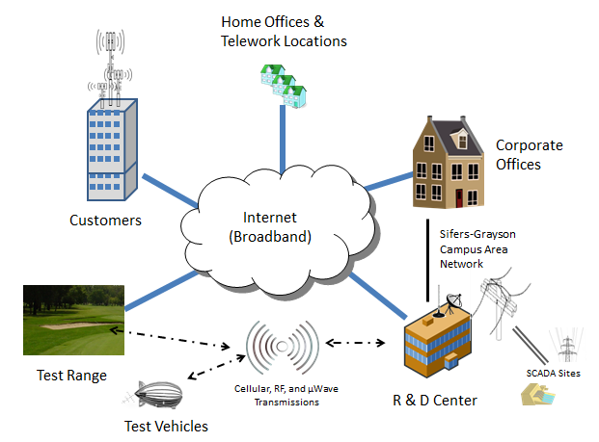
Figure 1. Overview of Sifers-Grayson Enterprise IT Architecture
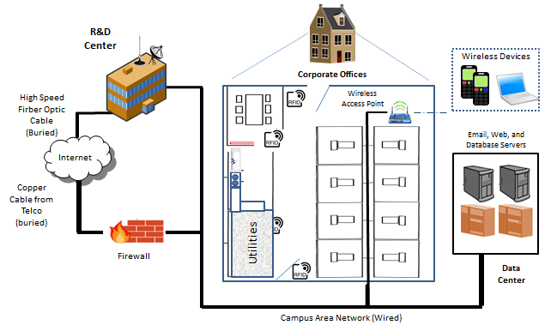
Figure 2. Combined Network and Systems Views:
Sifers-Grayson Headquarters, R&D Center, and Data Center

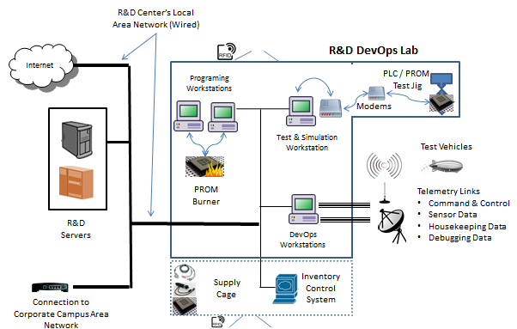
Figure 3. Combined Network and Systems View for Sifers-Grayson R&D DevOps Lab

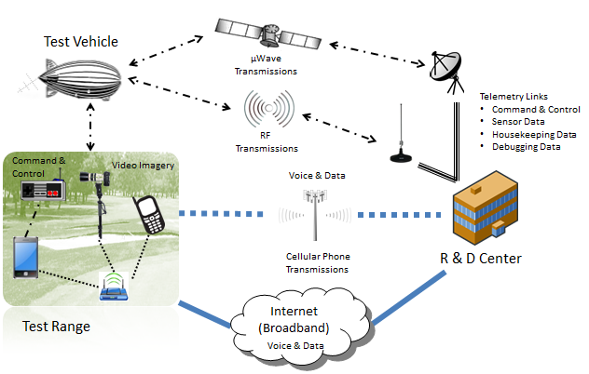
Figure 4. Combined Communications and Systems Views for Sifers-Grayson Test Range

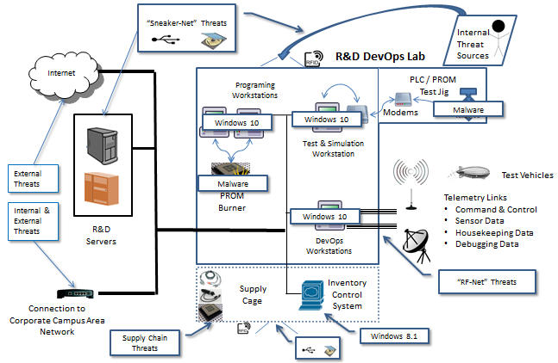
Figure 5. Threat Landscape for Sifers-Grayson R&D DevOps Lab

NIST Incident Handling Checklist by Phase
Detection and Analysis
1. | Determine whether an incident has occurred
1.1 | Analyze the precursors and indicators
1.2 | Look for correlating information
1.3 | Perform research (e.g., search engines, knowledge base)
1.4 | As soon as the handler believes an incident has occurred, begin documenting the investigation and gathering evidence
2. | Prioritize handling the incident based on the relevant factors (functional impact, information impact, recoverability effort, etc.)
3. | Report the incident to the appropriate internal personnel and external organizations
Containment, Eradication, and Recovery
4. | Acquire, preserve, secure, and document evidence
5. | Contain the incident
6. | Eradicate the incident
6.1 | Identify and mitigate all vulnerabilities that were exploited
6.2 | Remove malware, inappropriate materials, and other components
6.3 | If more affected hosts are discovered (e.g., new malware infections), repeat the Detection and Analysis steps (1.1, 1.2) to identify all other affected hosts, then contain (5) and eradicate (6) the incident for them
7. | Recover from the incident
7.1 | Return affected systems to an operationally ready state
7.2 | Confirm that the affected systems are functioning normally
7.3 | If necessary, implement additional monitoring to look for future related activity
Post-Incident Activity
8. | Create a follow-up report
9. | Hold a lessons learned meeting (mandatory for major incidents, optional otherwise)
Source: NIST SP 800-61r2
Cichonski, P., Millar, T., Grance, T., & Scarfone, K. (2012). Computer security incident handling guide (NIST SP 800-62 rev. 2). http://dx.doi.org/10.6028/NIST.SP.800-61r2

- Contact Information for the Incident Reporter and Handler
– Name
– Role
– Organizational unit (e.g., agency, department, division, team) and affiliation
– Email address
– Phone number
– Location (e.g., mailing address, office room number)
- Incident Details
– Status change date/timestamps (including time zone): when the incident started, when the incident was discovered/detected, when the incident was reported, when the incident was resolved/ended, etc.
– Physical location of the incident (e.g., city, state)
– Current status of the incident (e.g., ongoing attack)
– Source/cause of the incident (if known), including hostnames and IP addresses
– Description of the incident (e.g., how it was detected, what occurred)
– Description of affected resources (e.g., networks, hosts, applications, data), including systems’ hostnames, IP addresses, and function
– If known, incident category, vectors of attack associated with the incident, and indicators related to the incident (traffic patterns, registry keys, etc.)
– Prioritization factors (functional impact, information impact, recoverability, etc.)
– Mitigating factors (e.g., stolen laptop containing sensitive data was using full disk encryption)
– Response actions performed (e.g., shut off host, disconnected host from network)
– Other organizations contacted (e.g., software vendor)
- Cause of the Incident (e.g., misconfigured application, unpatched host)
- Cost of the Incident
- Business Impact of the Incident
- General Comments

